**LAB ASSESSMENT-3**

**SLOT: L55-L56**

**CSE 3501: INFORMATION SECURITY ANALYSIS AND AUDIT**

*Submitted By: Submitted to:*

*Sashank Rijal Chandra Mohan B*

*19BCE2484*

**Network Design:**

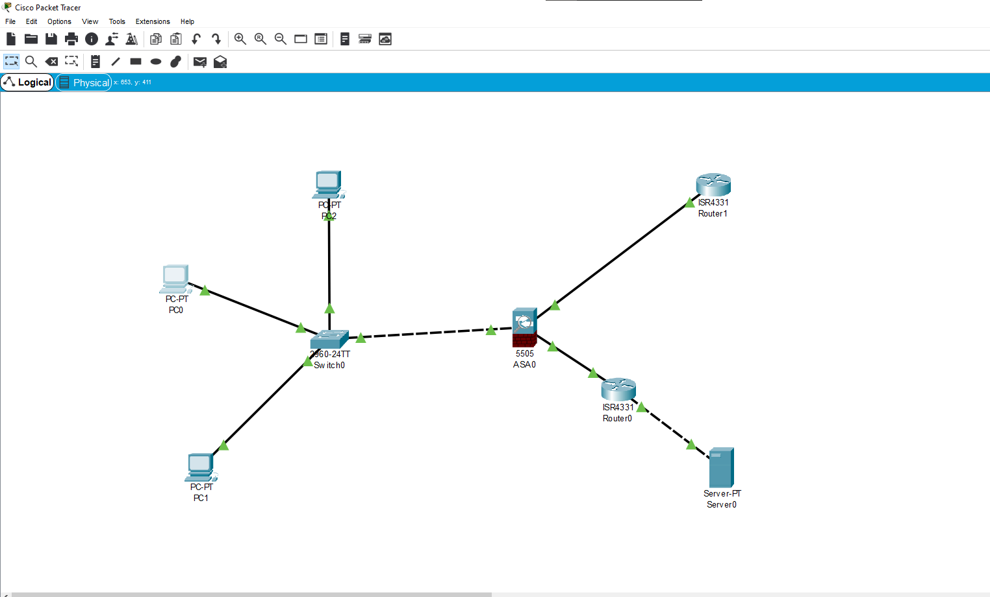

**Procedure:**

* Open cisco packet tracer and design the circuit with the given devices.
* Then, configure server by assigning it an IP address and giving default gateway. Go to its services and turn on the “DHCP” service.
* Interconnect the devices using appropriate wires.
* Now, configure the firewall and assign IP addresses to the PCs using DHCP.
* Go to firewall’s CLI and run the following commands:

ciscoasa(config)#access-list uti extended permit tcp any any

ciscoasa(config)#access-list uti extended permit icmp any any

ciscoasa(config)# access-group uti in interface outside

* Select anyone of the PCs and go to its command prompt. Then, ping the server using the command: ping -t server_ip_address

**Output:**



